VORON

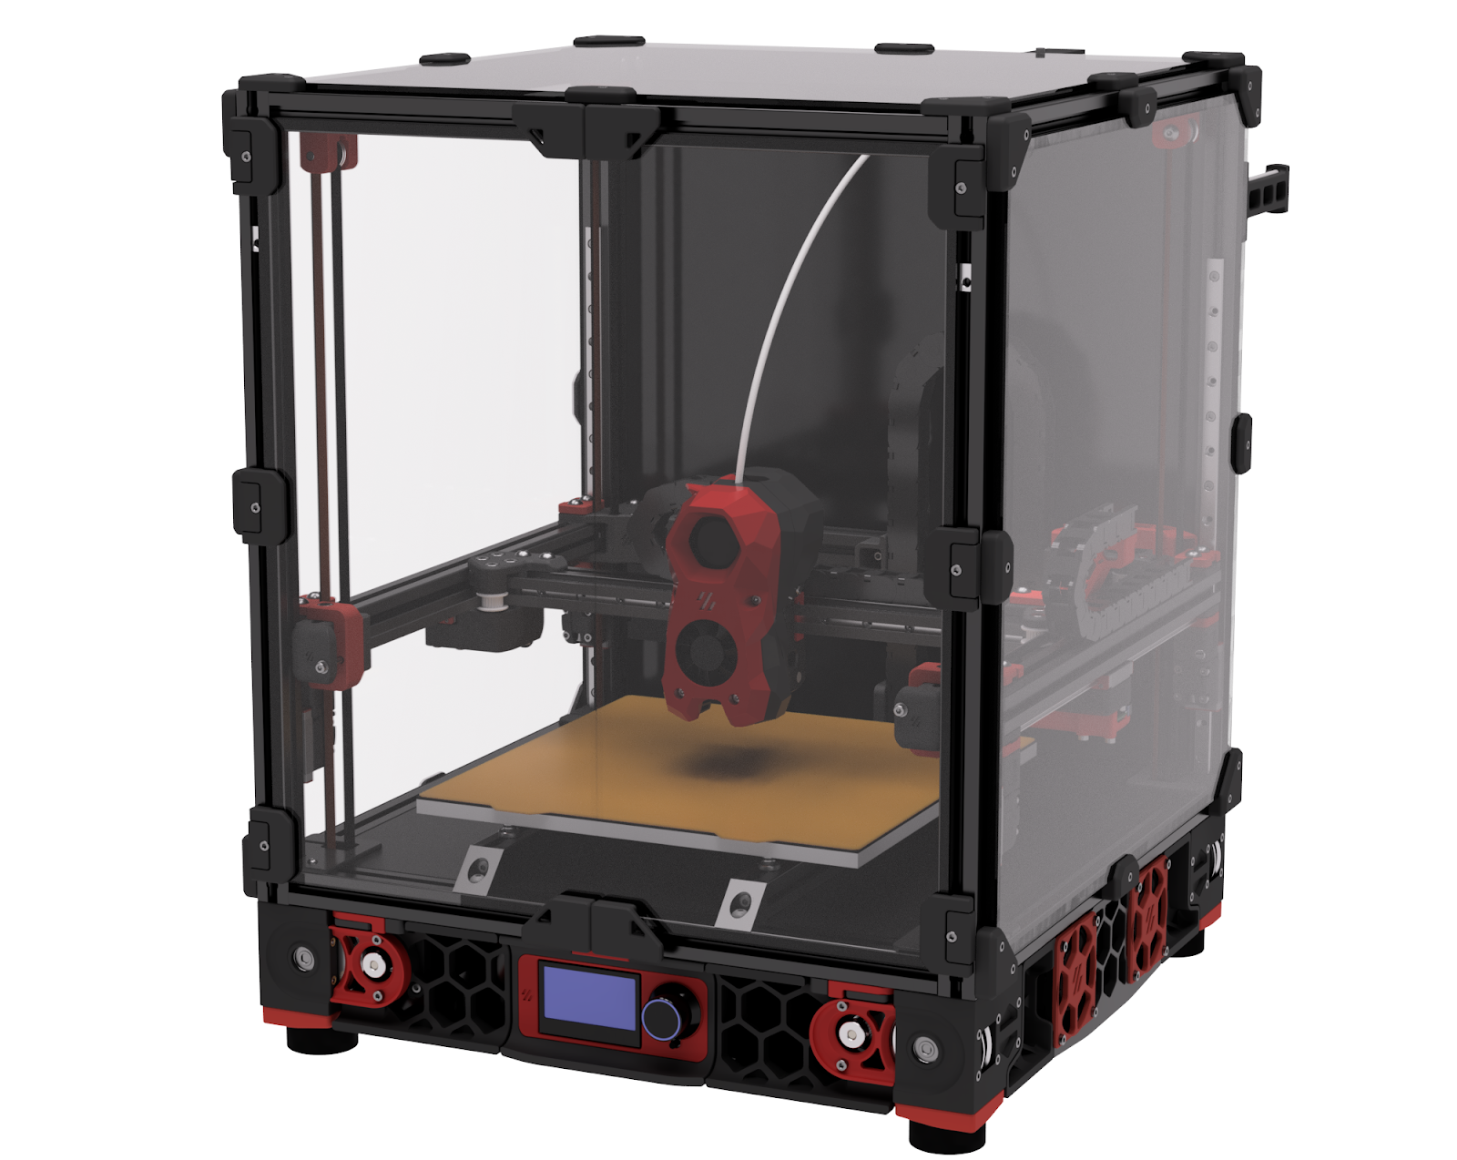
VORON2 2.4R2 BUILD GUIDE
We build space shuttles with gardening tools so anyone can have a space shuttle of their own.

INTRODUCTION



Before you begin on your journey, a word of caution.
In the comfort of your own home you are about to assemble a robot. This
machine can maim, burn, and electrocute you if you are not careful. Please
do not become the first VORON fatality. There is no special Reddit flair for that.
Please, read the entire manual before you start assembly. As you begin wrenching,
please check our Discord channels for any tips and questions that may halt your progress.
Most of all, good luck!
THE VORON TEAM

TABLE OF CONTENTS

Introduction | 04 | A/B Belts | 124
Hardware | 07 | Stealthburner | 146
Frame | 12 | Electronics | 148
Z Drives and Idlers | 22 | Controller | 174
Build Plate | 52 | Wiring | 180
A/B Drives and Idlers | 62 | Skirts | 212
Gantry | 82 | Panels | 240
Z Axis | 108 | Next Steps | 260

